**QUESTION 1:**

Take 5 subjects marks each subject 100 marks;calculate the percentage;based on the percentage print the grade and the percentage.

**PROGRAM WITHOUT FOR LOOP:**

import java.util.Scanner;

class Student2

{

public static void main(String args[])

{

int java,python,english,maths,android;

double total,avg,percent;

Scanner sc= new Scanner(System.in);

System.out.println("Enter the marks of Java:");

java=sc.nextInt();

System.out.println("Enter the marks of Python:");

python=sc.nextInt();

System.out.println("Enter the marks of English:");

english=sc.nextInt();

System.out.println("Enter the marks of Maths:");

maths=sc.nextInt();

System.out.println("Enter the marks of Android:");

android=sc.nextInt();

total = java + python +english + maths + android;

avg = (total / 5);

percent = (total / 500.0) * 100;

System.out.println("Total marks ="+total);

System.out.println("Average marks = "+avg);

System.out.println("Percentage = "+percent);

if(percent>=80 && percent<=100)

{

System.out.println("A Grade");

}

else if(percent>=60 && percent<80)

{

System.out.println("B Grade");

}

else if(percent>=40 && percent<60)

{

System.out.println("C Grade");

}

else

{

System.out.println("Fail");

}

}

}

**OUTPUT:**

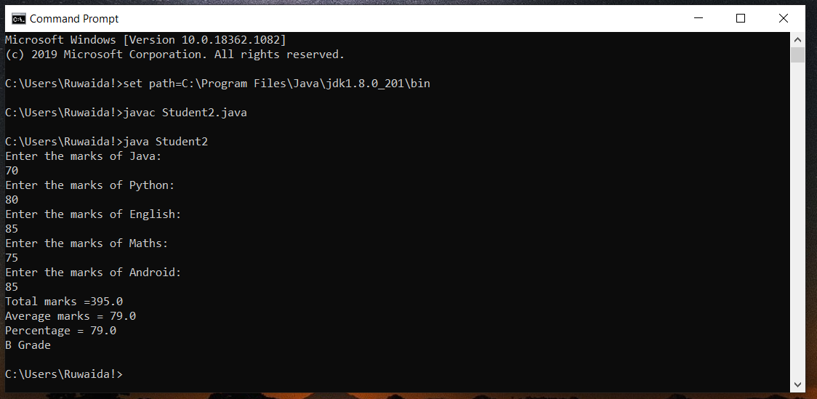

**PROGRAM WITHOUT FOR LOOP:**

import java.util.Scanner;

public class Calculate

{

public static void main(String args[])

{

int marks[] = new int[5];

int i;

float total=0, avg,percent;

Scanner scanner = new Scanner(System.in);

for(i=0; i<5; i++)

{

System.out.print("Enter Marks of Subject"+(i+1)+":");

marks[i] = scanner.nextInt();

total = total + marks[i];

}

scanner.close();

avg = total/5;

System.out.println("Average is:"+avg);

percent = (total / 500) * 100;

System.out.println("Percentage is:"+percent);

System.out.print("The student Grade is: ");

if(percent>=80)

{

System.out.print("A");

}

else if(percent>=60 && percent<80)

{

System.out.print("B");

}

else if(percent>=40 && percent<60)

{

System.out.print("C");

}

else

{

System.out.print("D");

}

}

}

**OUTPUT:**

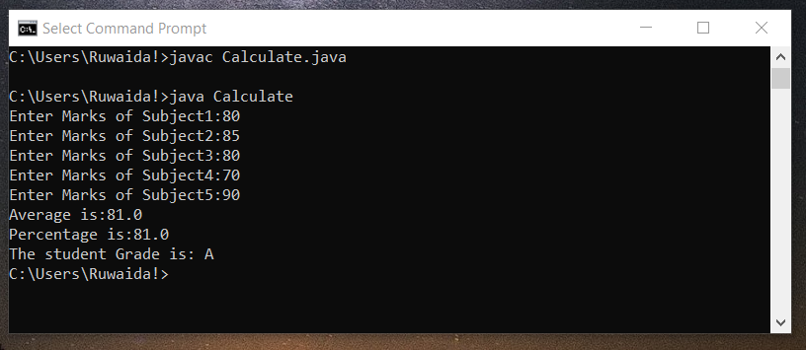

**QUESTION 2:**

Take employee name,date of birth,month of birth

birth year, monthly salary;

5l - 20%;

4l - 15%;

3l- 10%;

2l -5%;

Display name,age,annual salary and the tax amount.

**PROGRAM:**

import java.io.*;  
   
class Cal {  
    static void findAge(int current_date, int current_month,  
                    int current_year, int birth_date,  
                    int birth_month, int birth_year)  
    {  
        int month[] = { 31, 28, 31, 30, 31, 30, 31,    
                             31, 30, 31, 30, 31 };  
   
        // if birth date is greater then current    
        // birth_month, then donot count this month  
        // and add 30 to the date so as to subtract    
        // the date and get the remaining days  
        if (birth_date > current_date) {  
            current_month = current_month - 1;  
            current_date = current_date + month[birth_month - 1];  
        }  
   
        // if birth month exceeds current month,    
        // then do not count this year and add    
        // 12 to the month so that we can subtract  
        // and find out the difference  
        if (birth_month > current_month) {  
            current_year = current_year - 1;  
            current_month = current_month + 12;  
        }  
   
        // calculate date, month, year  
        int calculated_date = current_date - birth_date;  
        int calculated_month = current_month - birth_month;  
        int calculated_year = current_year - birth_year;  
   
        // print the present age  
        System.out.println("Present Age");  
        System.out.println("Years: " + calculated_year +    
              " Months: " + calculated_month + " Days: " +    
              calculated_date);  
    }  
    public static void main(String[] args)  
    {  
        // present date  
        int current_date = 7;  
        int current_month = 12;  
        int current_year = 2017;  
   
        // birth dd// mm// yyyy  
        int birth_date = 16;  
        int birth_month = 12;  
        int birth_year = 2009;  
   
        // function call to print age  
        findAge(current_date, current_month, current_year,  
              birth_date, birth_month, birth_year);  
    }  
}